Section 02: Project Deliverables
This section details all of the items that the project team will deliver to BINCOL by the end of the ten-week capstone timeline, constructing directly off from both the scope defined in Section 1.4 and objectives laid out in Section 1.3. All deliverables are organized by project phase — Planning, Risk Management, Design, Development, Testing, Deployment & Training and Project Closure with traceability back to functional and non-functional requirements described in Section 3.
2.1 Planning Phase Deliverables
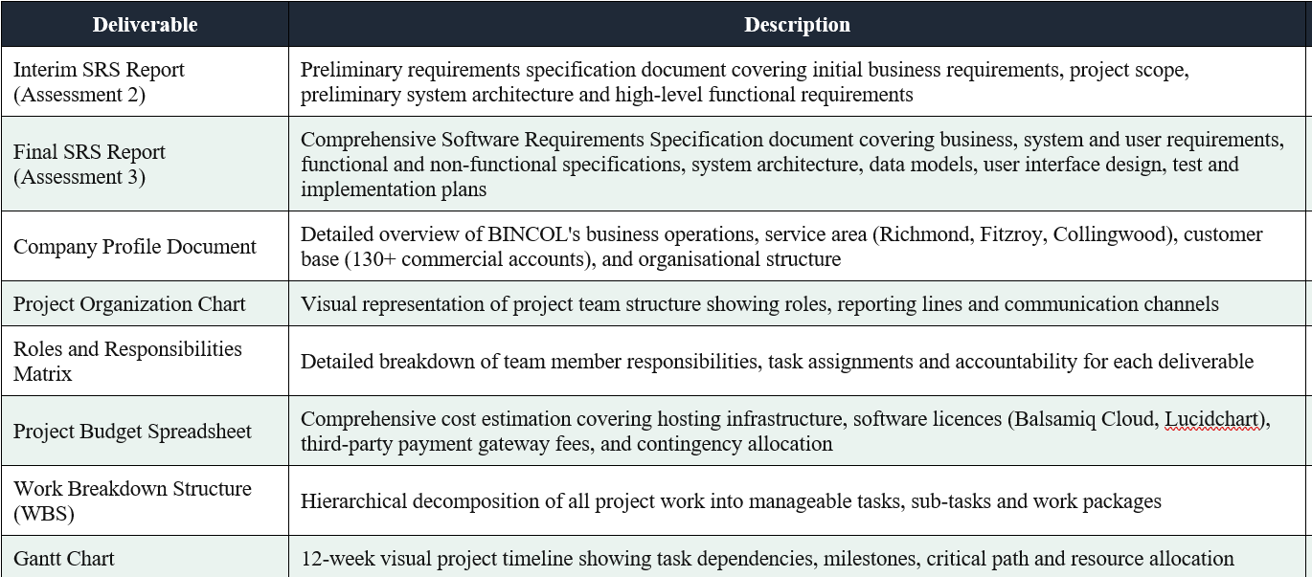
2.2 Risk Management Phase Deliverables
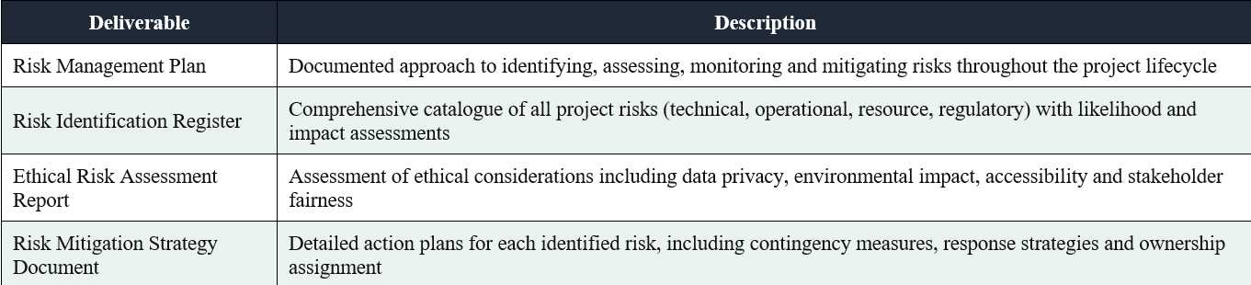
2.3 Design Phase Deliverables
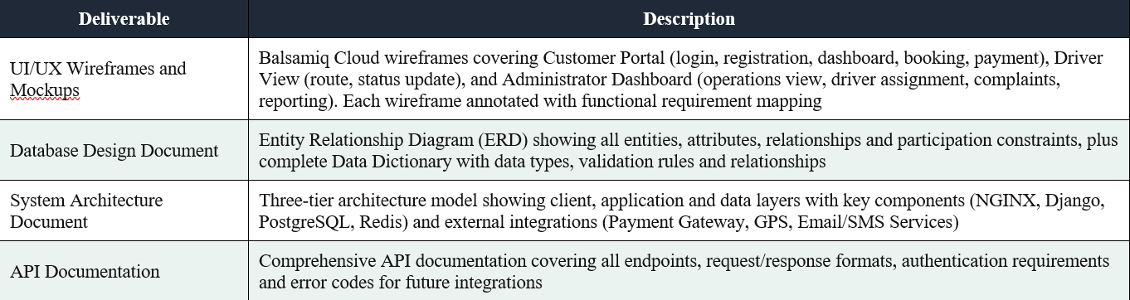

2.4 Development Phase Deliverables
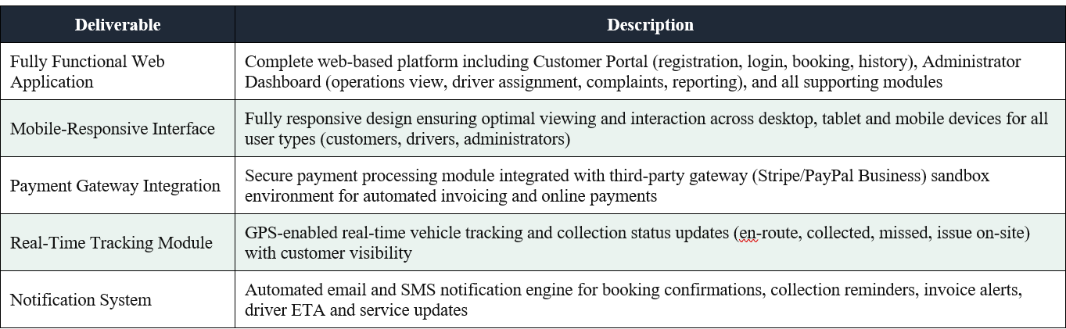
2.5 Testing Phase Deliverables
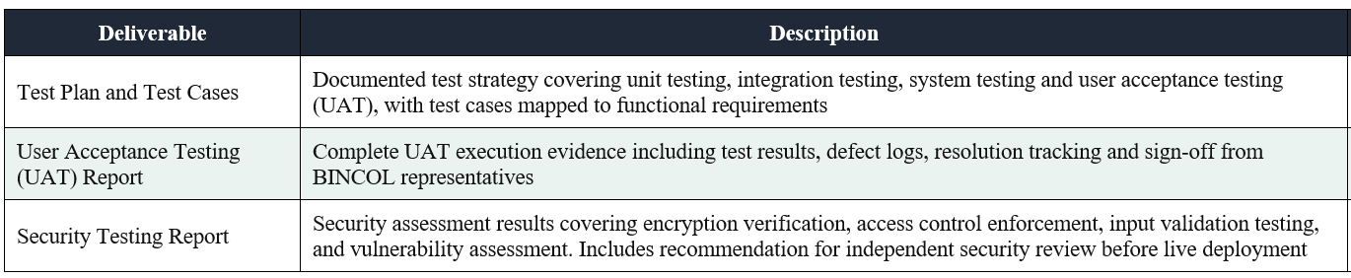
2.6 Deployment & Training Phase Deliverables
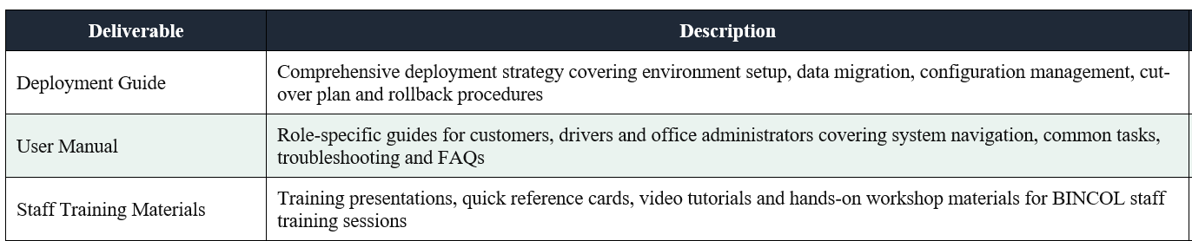
2.7 Project Closure Deliverables
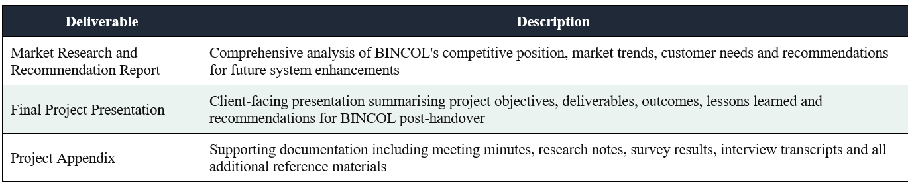

2.8 Deliverable Summary Table
